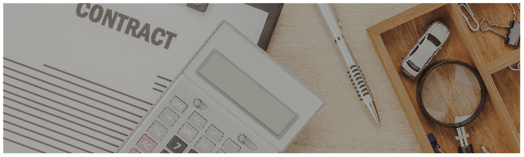
Sales CONTRACT
This Sales Agreement (“Agreement”) is made and entered into as of [Effective Date] (the “Effective Date”), by and between: [Seller's Name], located at [Seller's Address] (the “Seller”), and [Buyer’s Name], located at [Buyer’s Address] (the “Buyer”), collectively referred to as the “Parties.”

1. Background
The Seller is the Seller / Manufacturer / Distributor of the following product(s):
[List of product(s) to be inserted here].
The Buyer hereby intends to purchase the above-referenced product(s).

2. Sale of Goods
- The Seller agrees to make available, sell, transfer, and deliver to the Buyer the following goods (the “Goods”) on or before: [Delivery Deadline Date].
- The Buyer agrees to purchase the Goods as detailed in Exhibit A attached to this Agreement.

3. Other Provisions
- Other: [Insert any additional relevant terms or write “N/A”].

4. Purchase Price and Payment Terms
- The Seller hereby agrees to sell the defined Goods to the Buyer for the total purchase price of: [Purchase Price] (the “Purchase Price”).
- The Seller shall provide an invoice to the Buyer upon delivery of the Goods.
- The Buyer agrees to pay all invoices in full within [Number of Days] days of receipt.
- Any amount not paid within [Number of Days] days shall incur a [Late Payment Penalty Rate]% late payment penalty.
- The Seller retains a security interest in the Goods until full payment is received.

5. Delivery
- The Seller shall deliver the Goods to the Buyer at the following address:
[Delivery Address].
- The Seller agrees to deliver the Goods on or before the following date(s), unless otherwise agreed in writing by the Parties:[Delivery Date(s)].

IN WITNESS WHEREOF, the Parties have executed this Sales Agreement as of the Effective Date written above.
SELLER |  |  |  |  |  |  |  |  |  |  | BUYER
Seller's Name |  |  |  |  |  |  |  |  |  |  | Buyer’s Name
Enter a date |  |  |  |  |  |  |  |  |  |  | Enter a date

Signature |  |  |  |  |  |  |  |  |  |  | Signature

